Lab 3
Manual Trace of BFS and DFS
Nouman Ali
Su92-bsaim-f25-118
AI-3B

1. Problem and Graph
Trace Breadth-First Search (BFS) and Depth-First Search (DFS) on the original A–G graph provided in Section 3.2 of the lab manual. The start node is A and the goal node is G. Successors are considered in the given left-to-right order, and the search stops when G is processed.
Graph adjacency list: A → [B, C]; B → [D, E]; C → [F]; D → []; E → [G]; F → []; G → [].
Depth is measured in edges, so A is at depth 0. For DFS, neighbours are pushed in reverse order so the first listed neighbour is processed first.
2. Breadth-First Search (BFS)
BFS uses a FIFO queue. The queue is shown from front to rear. The processed node is removed from the front; unseen successors are then appended in successor order. Paths are recorded for each queued node.
Step | Processed node | Queue after expansion | Path to processed node | Action / note
0 | — | [A] | — | Initial queue
1 | A | [B, C] | A | Append B, then C
2 | B | [C, D, E] | A → B | Append D, then E
3 | C | [D, E, F] | A → C | Append F
4 | D | [E, F] | A → B → D | No successors
5 | E | [F, G] | A → B → E | Append G
6 | F | [G] | A → C → F | No successors
7 | G | [] | A → B → E → G | Goal processed; stop
BFS visit order (processed nodes): A, B, C, D, E, F, G.
BFS returned path: A → B → E → G (3 edges).
3. Depth-First Search (DFS)
DFS uses a LIFO stack. The stack is shown from top to bottom (the next node to pop is first). Successors are pushed in reverse order to preserve the graph’s left-to-right visitation order. The supplied code checks for an already-seen node when it is popped; duplicate entries are skipped.
Step | Processed node | Stack after expansion | Path to processed node | Action / note
0 | — | [A] | — | Initial stack (top first)
1 | A | [B, C] | A | Push C, then B; B is on top
2 | B | [D, E, C] | A → B | Push E, then D; D is on top
3 | D | [E, C] | A → B → D | No successors
4 | E | [G, C] | A → B → E | Push G
5 | G | [C] | A → B → E → G | Goal processed; stop
DFS visit order (processed nodes): A, B, D, E, G.
DFS returned path: A → B → E → G (3 edges).
4. Verification Against the Supplied Code
The supplied BFS code uses a deque as a FIFO queue and marks nodes seen when they are enqueued. The supplied DFS code uses a stack, pushes reversed successors, and skips nodes already seen when popped. For the given graph and start/goal pair, both implementations return the path A → B → E → G.

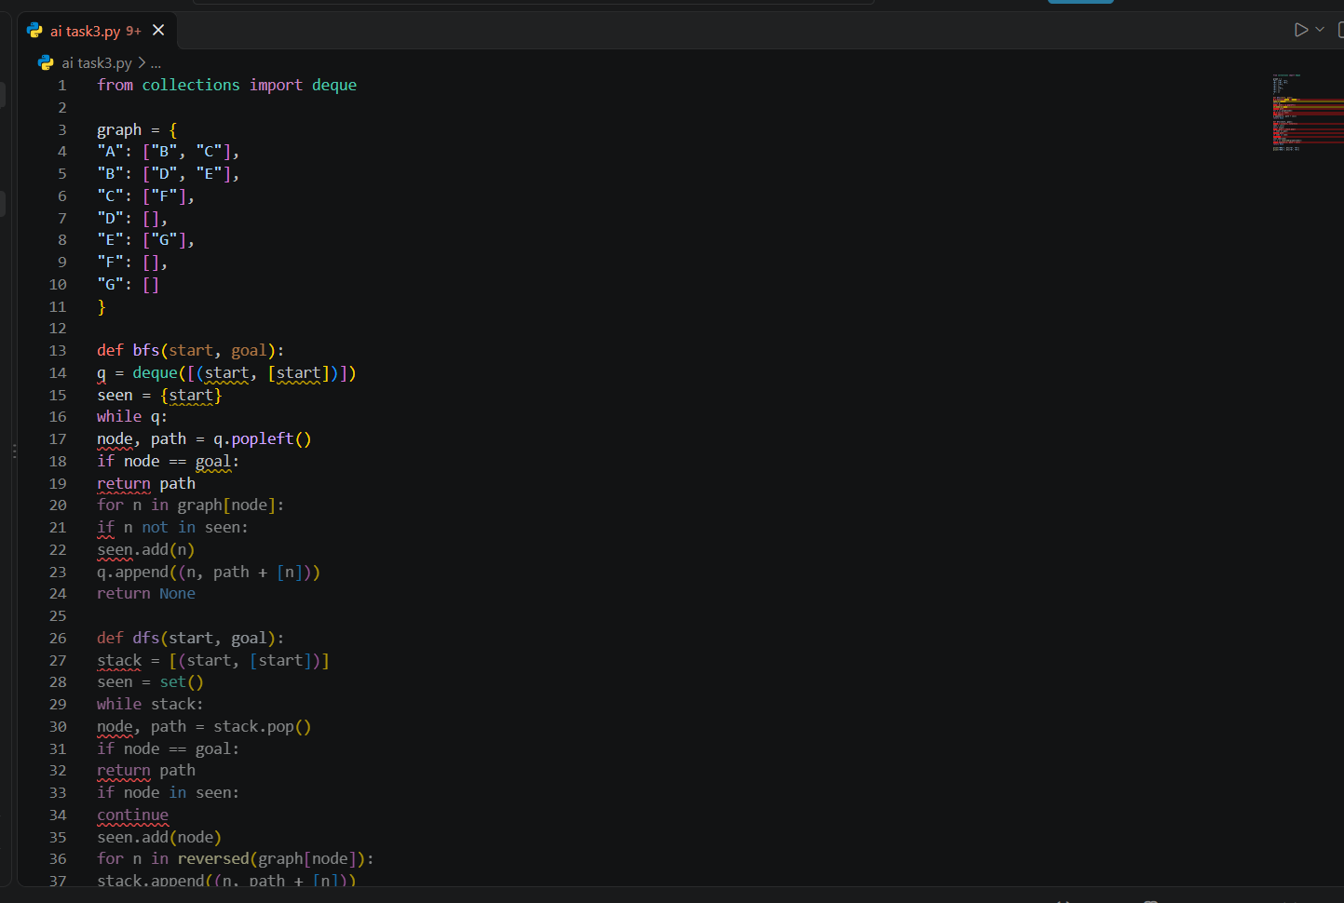

5. Expected Output
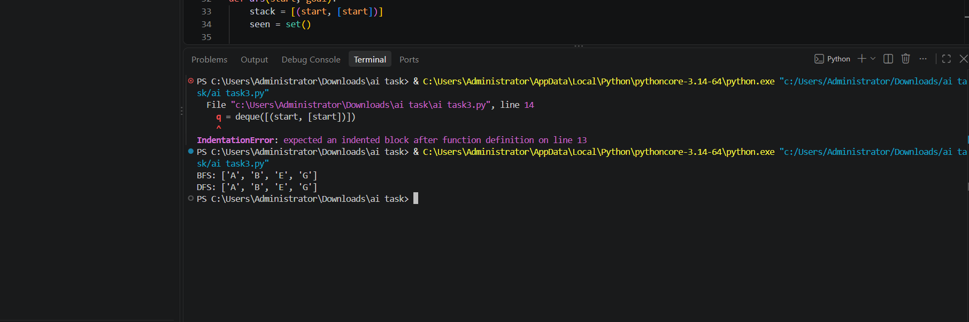

6. Conclusion
BFS processes nodes level by level and, with this successor order, visits A, B, C, D, E, F, G. DFS follows the first available branch deeply, visiting A, B, D, E, G before the goal is reached. Both return A → B → E → G because the original graph has only one route from A to G. The visit order and the returned path are different kinds of evidence and should be reported separately.

Task 2
Depth-Limited Search and Iterative Deepening DFS
1. Problem Setup
This task implements Depth-Limited Search (DLS) and Iterative Deepening Depth-First Search (IDDFS) on the original graph from Section 3.2 of the lab manual. Start = A, goal = G, and the root has depth 0. Successor order is preserved: A:[B,C], B:[D,E], C:[F], D:[], E:[G], F:[], G:[].
DLS returns FOUND when the goal is found, CUTOFF when a node at the depth limit has unexplored successors that could lead deeper, and FAILURE when the reachable branch is exhausted without hitting the limit or finding the goal. A path-local set prevents cycles along the current path but permits valid revisits in other branches.
2. Python Implementation
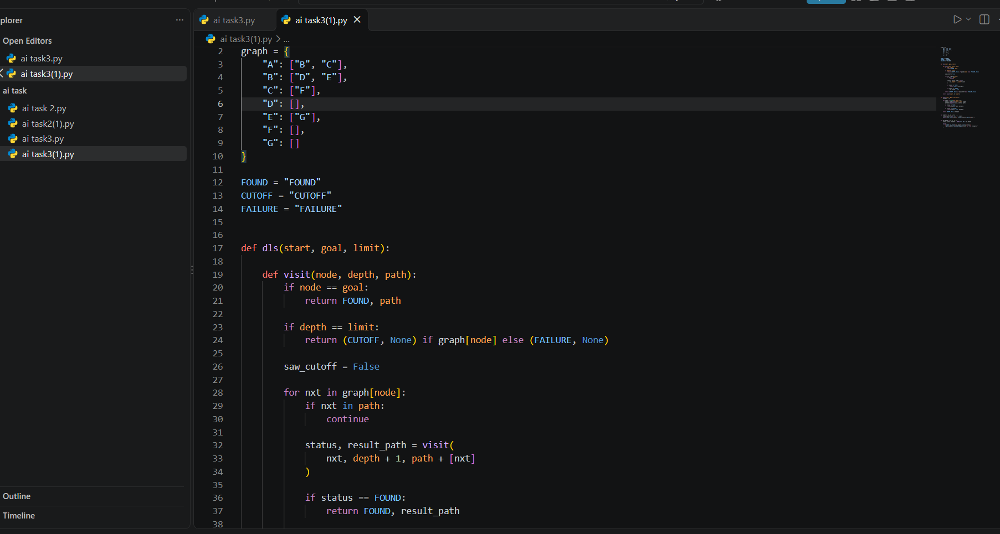
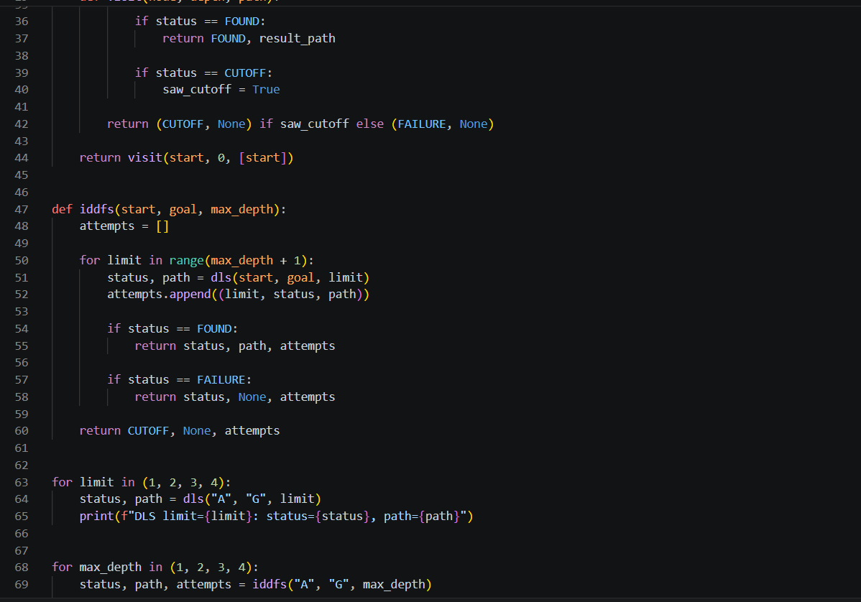
Output:

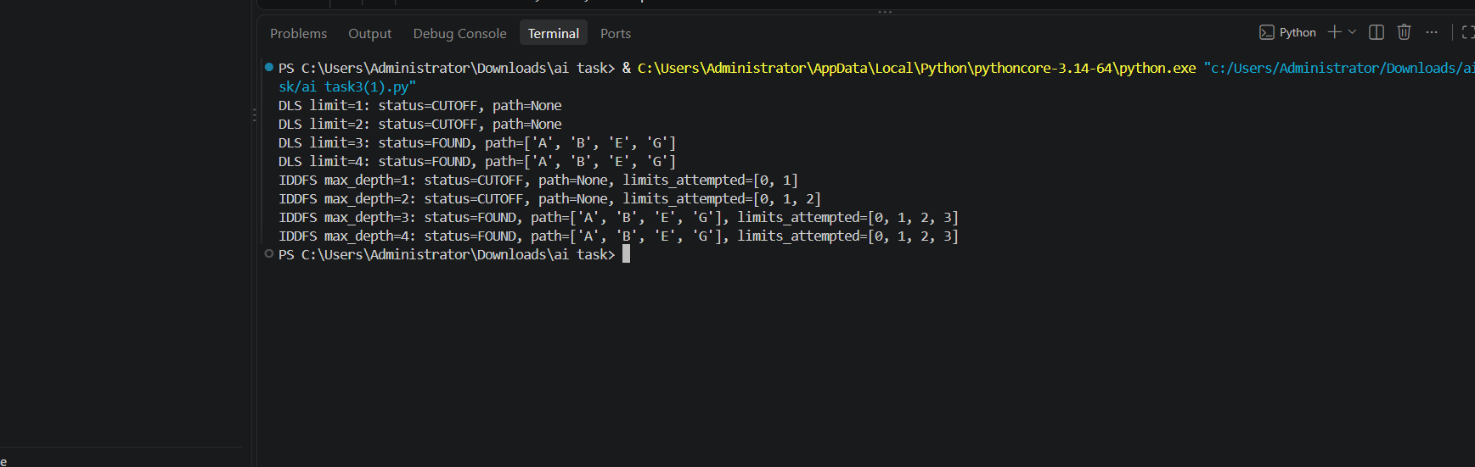

3. DLS Results
Predicted and observed results for each requested limit (root A is depth 0):
Depth limit | Status | Returned path | Explanation
1 | CUTOFF | None | At depth 1, B and C have successors; G is deeper.
2 | CUTOFF | None | At depth 2, E and F have successors; G is at depth 3.
3 | FOUND | A → B → E → G | Goal G is reached exactly at depth 3.
4 | FOUND | A → B → E → G | Goal is found before the search needs to reach depth 4.
4. IDDFS Results
IDDFS starts at limit 0 and increases the limit by one, using a fresh path-local check on each iteration. The table lists all limits attempted before success or the specified maximum.
Maximum depth | Final status | Returned path | Limits attempted
1 | CUTOFF | None | 0, 1
2 | CUTOFF | None | 0, 1, 2
3 | FOUND | A → B → E → G | 0, 1, 2, 3
4 | FOUND | A → B → E → G | 0, 1, 2, 3
5. Expected Output
DLS limit=1: status=CUTOFF, path=None
DLS limit=2: status=CUTOFF, path=None
DLS limit=3: status=FOUND, path=['A', 'B', 'E', 'G']
DLS limit=4: status=FOUND, path=['A', 'B', 'E', 'G']
IDDFS max_depth=1: status=CUTOFF, path=None, limits_attempted=[0, 1]
IDDFS max_depth=2: status=CUTOFF, path=None, limits_attempted=[0, 1, 2]
IDDFS max_depth=3: status=FOUND, path=['A', 'B', 'E', 'G'], limits_attempted=[0, 1, 2, 3]
IDDFS max_depth=4: status=FOUND, path=['A', 'B', 'E', 'G'], limits_attempted=[0, 1, 2, 3]
6. Interpretation and Edge Case
Limits 1 and 2 do not reach G because the solution is at depth 3. Their result is CUTOFF, not FAILURE, because a deeper continuation remains beyond the limit. At limits 3 and 4, the goal is found and the returned path is A → B → E → G.
IDDFS repeats work: nodes near the root are visited again at each new limit. This extra work is the trade-off for DFS-like memory use while finding the shallowest solution when step costs are equal. The search must not carry a global visited set between limits, because a node reached at a shallower depth in one iteration could be incorrectly blocked in a later one.
Edge-case test: start equals goal (start='A', goal='A', limit=0) should return FOUND with path ['A']. An unreachable goal in a finite graph should eventually return FAILURE once all reachable branches are exhausted and no cutoff remains.
7. Conclusion
DLS reaches G only when the depth limit is at least 3. IDDFS discovers the same path after attempting limits 0, 1, 2 and 3 when the maximum depth is 3 or 4. Correctly distinguishing CUTOFF from FAILURE and using path-local cycle checking are essential to reliable depth-limited search.
Source: AI Lab Manual, Lab 3, Sections 3.2, 3.5, 3.6 and Lab Task 2 (pages 13–15).

Task 3
Uniform-Cost Search on a Weighted Graph
1. Problem Setup and Assumptions
Task 3 asks for a weighted version of the original A–G graph, Uniform-Cost Search (UCS), the weight of every edge, the UCS processing order, an independently summed path cost, and a comparison with BFS on the same weighted topology.
Following Section 3.7 of the lab manual, the original vertices and corridors are retained and the extra corridor C → G is explicitly added. The manual states that on this extension BFS can choose A → C → G with cost 12, while UCS finds A → B → E → G with cost 3. The manual does not list every individual edge weight, so the following nonnegative assignment is an explicit illustrative assignment consistent with those stated totals.
2. Weighted Graph
Directed edges and travel-cost units:
From | To | Cost
A | B | 1
A | C | 2
B | D | 5
B | E | 1
C | F | 5
D | — | No outgoing edge
E | G | 1
F | — | No outgoing edge
C | G | 10
G | — | Goal
For clarity, the added corridor is C → G with cost 10. Together with A → C cost 2, this makes the two-edge BFS route A → C → G cost 2 + 10 = 12. The three-edge route A → B → E → G costs 1 + 1 + 1 = 3.
3. Python Implementation of UCS and BFS
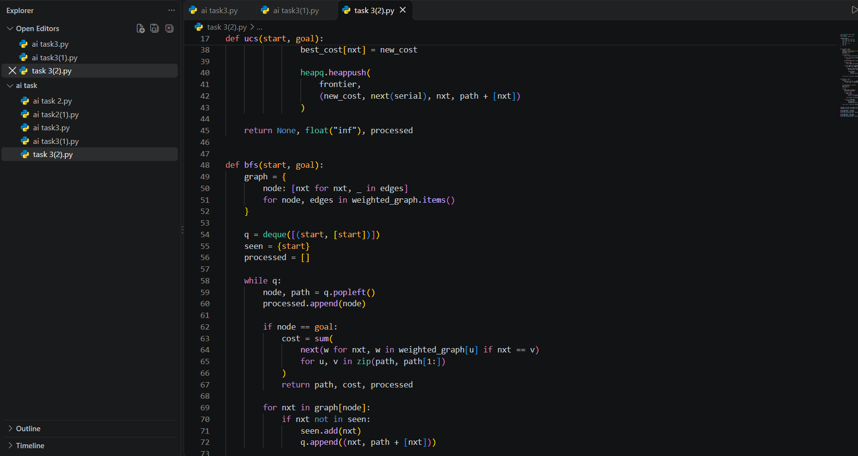
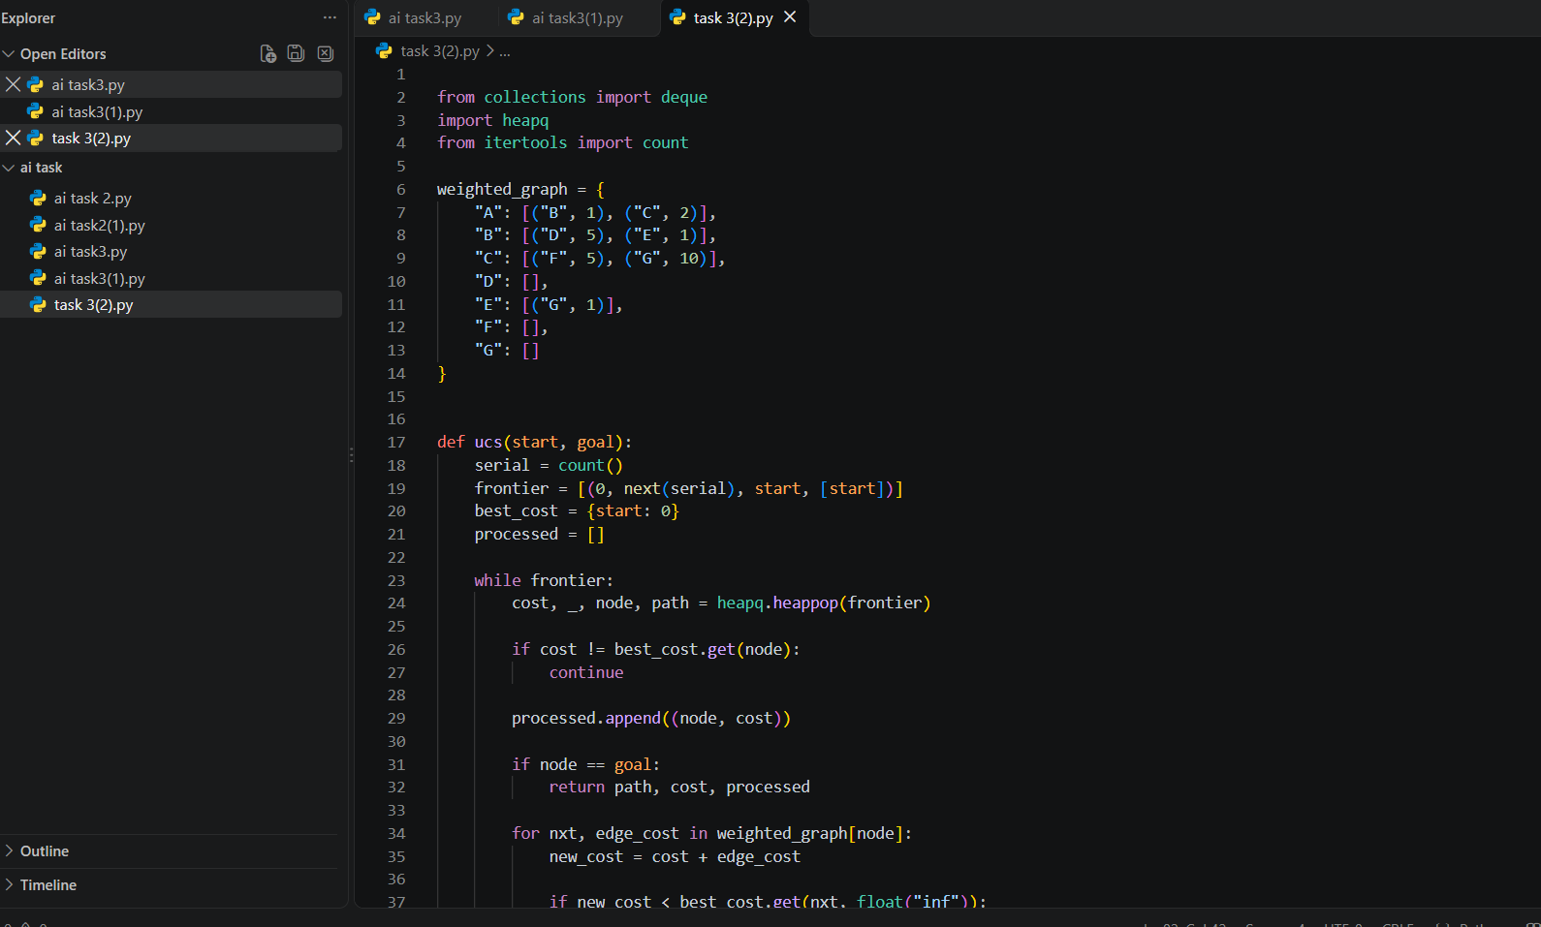
Output:

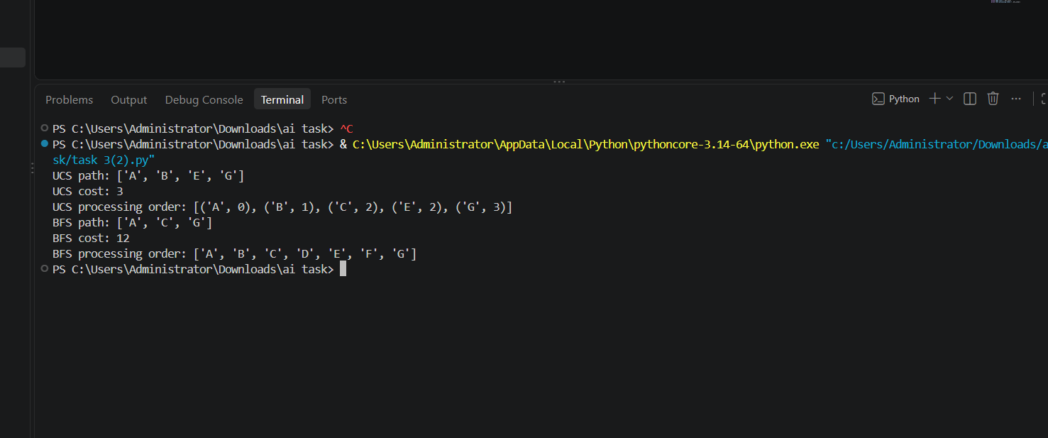

4. UCS Processing Trace
The priority queue is ordered by cumulative cost. With the stated successor order and insertion-order tie-breaking, the nodes are processed as follows. A node is processed when removed from the priority queue with its current best cost.
Processed node | Cumulative cost | Frontier after expansion (cost) | Explanation
A | 0 | B:1, C:2 | Expand A; add B and C
B | 1 | E:2, C:2, D:6 | Expand B; E is cost 2 and D is cost 6
E | 2 | C:2, G:3, D:6 | Expand E; add G at cost 3
C | 2 | G:3, D:6, F:7 | Expand C; G via C costs 12, not better; add F at 7
G | 3 | D:6, F:7, G:12 (stale) | Goal popped at optimal cost 3; stop
5. Results and Independent Cost Check
Algorithm | Returned path | Number of edges | Independently summed cost
BFS | A → C → G | 2 | 2 + 10 = 12
UCS | A → B → E → G | 3 | 1 + 1 + 1 = 3
UCS processing order: A(0), B(1), E(2), C(2), G(3). The tie at cumulative cost 2 is resolved by insertion order: E was inserted while expanding B before the equal-cost C was removed, so E is processed first.
BFS processing order on this adjacency order: A, B, C, D, E, G. BFS returns A → C → G because it minimizes edge count, not travel cost. UCS returns A → B → E → G because total cost 3 is lower than 12.
6. Edge Case / Test
Start-equals-goal test: running UCS with start='A' and goal='A' should immediately return path ['A'] with cost 0. A nonnegative-cost unreachable-goal test should exhaust the priority queue and return no path (infinity in this sample implementation). UCS assumes nonnegative edge weights; negative costs are outside the assumptions of this task.
7. Conclusion
On the weighted extension, BFS chooses the route with the fewest edges, A → C → G (2 edges, cost 12), while UCS chooses the minimum-cost route A → B → E → G (3 edges, cost 3). This demonstrates that fewer hops do not necessarily mean lower travel cost. The added corridor C → G and all edge weights are explicitly documented for reproducibility.
Source note: The lab manual's Section 3.7 specifies the added C → G corridor and the comparison totals (BFS cost 12, UCS cost 3), but does not provide each edge's individual weight in the supplied text. The edge assignment in this report is therefore an explicit consistent example, not a verbatim weight table from the manual.
Source: AI Lab Manual, Lab 3, Sections 3.2, 3.7, 3.8 and Lab Task 3 (pages 13–15).

